1. **Till Now**:
   1. We wrote unit tests for individual layers (Controller using @WebMvcMock, Service no special annotation, Data Layer using @DataJpaTest).
2. **Agenda**:
   1. Let’s write integration test combining all the layers together.
3. @SpringBootTest:
   1. This annotation will lunch the spring boot application.
   2. Graphical user interface, text, application

      Description automatically generated with medium confidence
   3. **@SpringBootTest**(webEnvironment=WebEnvironment.RANDOM_PORT)
      1. We don’t want to run app on some port each time we run integration spring boot test.
      2. This value will pick one available port.
      3. Why using Random Port?
      4. Suppose you’re using Continuous Integration Server where you’re integration tests will run. So, when you commit your changes, your test cases run on continuous Integration Server, you don’t want app to use the same port. That is where RANDOME PORT comes into picture.
4. 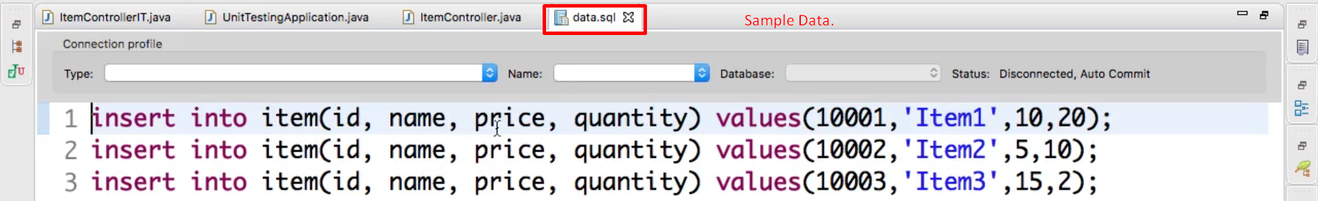
5. Graphical user interface, text, application

   Description automatically generated